Southern Colonies

This region is made up of five colonies:

- ________________________

- ________________________

- ________________________

- ________________________

- ________________________
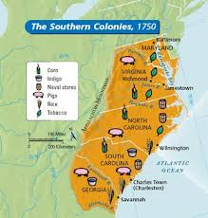  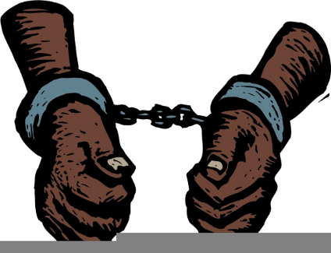  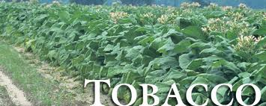 | Southern Geography & Economy  This region has a _________________ climate than other parts of the colonies  This region features broad ______________ and vast ________________ that gradually merged with the sea.  Here the soil and hot wet climate was ideal for growing cash crops like ______________, ____________, ___________, and Indigo.  Cash Crop: These are crops that are grown in large quantities in order to be sold for a ___________.  Plantation owners relied on enslaved ___________ to sow and harvest their fields as well as Indentured Servants:  Indentured Servant: _______  Each plantation was a large-scale farming operation on which ____ or more slaves worked ______________ to be shipped to other colonies and to __________ in exchange for manufactured goods.

