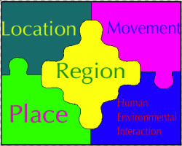 | 5 Themes of Geography  _____________: Where something is  _________: Describes the physical & human characteristics of a place  __________: Describes the similarities you find in a place  _______________: Describes how people, good, and information got to a place  __________________________: Describes how humans have changed a certain place
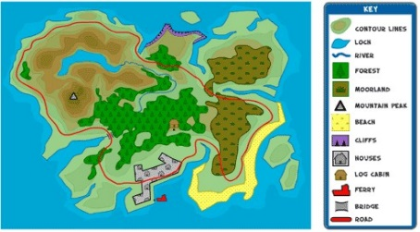 | Map Key [Legend]  The map key _____________ the ________________ of all the _______________ on a map. This information usually appears in a _________ near the edge of a map.
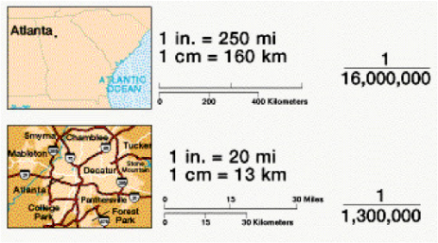 | Map Scale  A ____________ is the relationship between a ______________________ on the __________ and the actual _________________ on Earth’s surface.
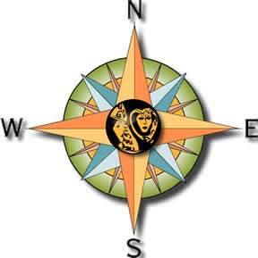 | Compass Rose  The _______________ Rose points to all __________ ___________________ points.  North, _____________ , East, and _____________
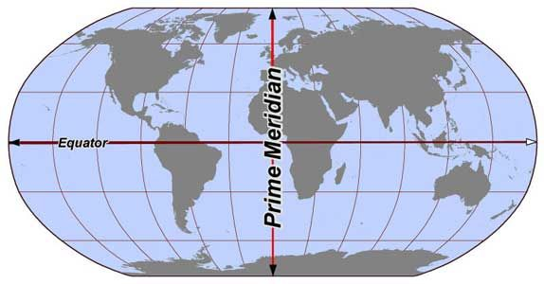 | Latitude  Latitude lines measure distance ____________ and ____________ of the EQUATOR. The _______________ is an imaginary line circling the _____________ exactly ________________ between the North & South Poles at 0 degrees. It divides the Earth into Northern & __________________ Hemispheres.
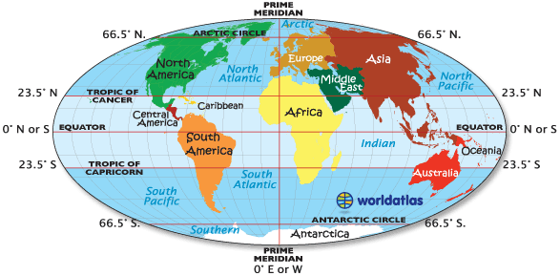 | Longitude  Longitude lines measure distance _____________ and _____________ of the PRIME MERIDIAN. The Prime _______________ is an imaginary line circling from North & South Poles at 0 degrees. It divides the Earth into Eastern & _______________ Hemispheres.

