Mapping Skills

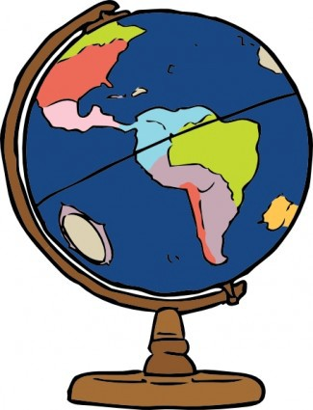
The world is a large place. Even the town or city you live in can be quite big. How can you know where you live in the world in relation to other places? If you want to travel somewhere how do you know where to go?

The answer is - you need a MAP.

What is a map?
A map is a simplified depiction of space. It is a visual representation of an area of land or sea and it shows the physical features of an area, such as cities, roads, mountains, rivers and many more things.

Maps show the relationship between objects within an area. For example, a map of your town can show you the distance between your school and home and the roads to travel on to get from home to school.

Maps are used as navigational aids, to help people get from one place to another.

There are many types of maps, such as street maps, weather maps and political maps, which all tell us lots of information.

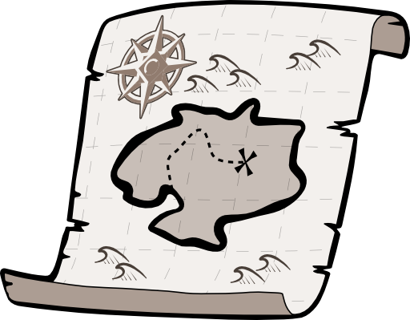
All maps have a few things in common. It is important you learn the elements of a map in order for you to be able to create maps, but more importantly and practically, for you to be able to use maps in your everyday life.

All maps have a few features that can be easily remembered with an acronym - B.O.L.T.S.S.
Let us take a look at what each of these letters stand for:

All maps must have a border around the outside of the map. This
B stands for Border
shows the edges of the map, indicating the limits of the particular map. When creating your own maps make sure your border is a ruled clear bold box around your map.

Orientation means direction. Sometimes a map might just show a north arrow, indicating the direction of north. Sometimes the map may show a full compass.
O stands for orientation

This is a list on your map, or sometimes to the side or bottom of your map that shows all the symbols that are used in a map and what they each represent.
L stands for legend

Every map must have a heading that tells us what the map is about. For example: World Political Map, or City Centre of Melbourne, or Map of Wallingwood Elementary School.
T stands for Title

A map cannot really be big enough to show us the exact size of
S stands for scale
things or distance between places. Can you imagine a life-sized map of your town? Instead maps are made smaller than real life. They need a scale that shows us how much smaller the map is to real life.

The second
S stands for Source
from to create the map.
Here you need to include where you got the information

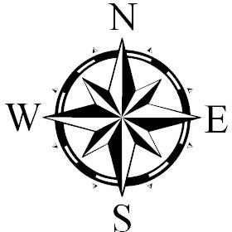TASK
Have a look at the map below.
On the map mark and name all the elements of BOLTSS that you can see. They are all there!
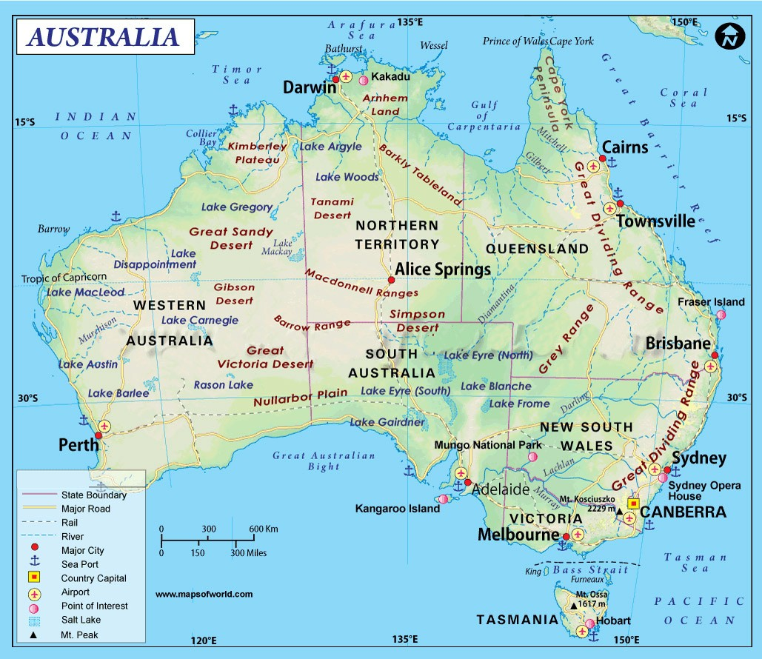
Some of these mapping elements are easy to understand, but some need a little further explanation. Let us look at some of these elements in more detail.

Orientation
Orientation refers to the compass direction of a map. A compass contains a magnetized needle that always points north. Because of this we can use compass points to know the direction of the places in our map.
All compasses have 4 main points, (which are called cardinal points)
➢➢ North
➢➢ South
➢➢ East
➢➢ West

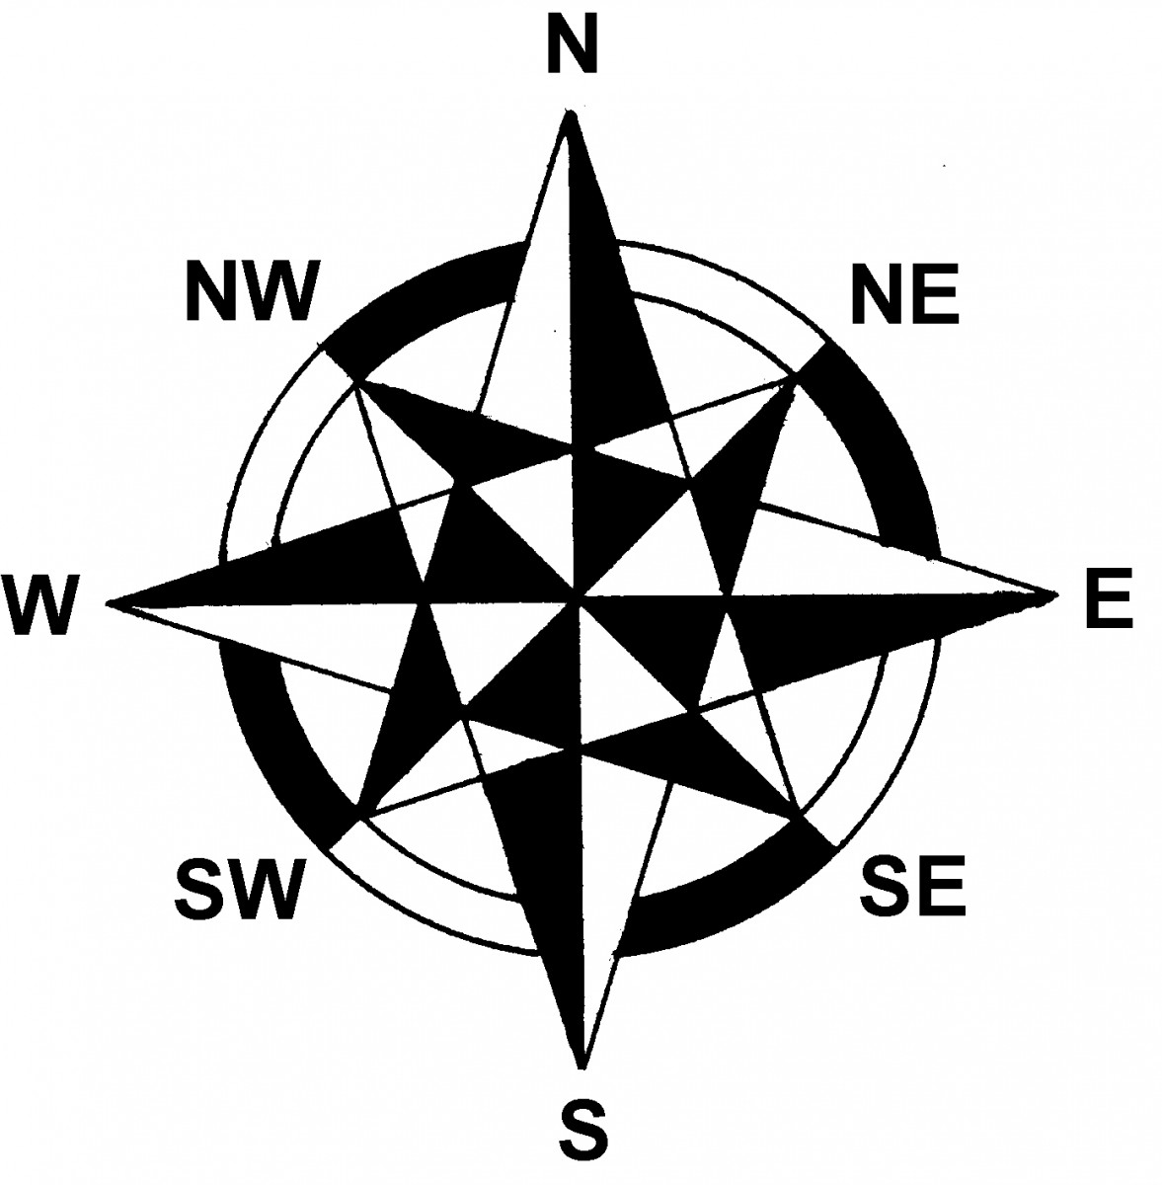
North and South are opposite each other, so if you are facing North, then South is behind you. East and West are also opposite each other.

There are also four inter-cardinal points:
➢➢ North East
➢➢ North West
➢➢ South East
➢➢ South West

Compass points are used to describe the direction of travel, for example “I drove south to reach the beach”, or the position of one place in relation to another, for example “The city is north west of the mountain range.”

Legend
Maps contain a lot of information and it is difficult to write the names of everything onto the map. It would look too messy. Maps therefore use symbols to represent different elements on the map. Symbols need to be clear and easily recognizable.
The symbols are then listed in a table called a Legend to explain what they each mean.

TASK
Here are a few commonly used mapping symbols. Can you match the name below with the correct symbol?

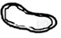

Title: Road Swamp Railway

Airport Lake Track

River
Picnic ground Bridge

Scale
The scale on a map tells us how much the real size of the area on a map has been ‘scaled’ down.
There are a couple ways scale can be shown on a map, so you need to be familiar with each of them.
- Linear scale – this is a numbered line that shows how much of an actual area is represented by a smaller area. For example, 1 centimeter can represent 1 kilometer on a map, or 1 inch may represent 1 mile.

Here are some examples of what linear scales may look like:

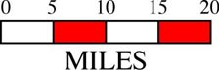

- Ratio scale – This way shows the scale as numbers. For example, if 1 cm on a map equals 1 kilometer in reality it would be written as 1:10000. If 1 inch represented one mile it would look like this: 1:63330

TASK
Try and have a go working out the distance between places. Look at the map below. You can see the scale is shown in both kilometers (the top lines) and miles (the bottom lines)

Work out approximately the distance between the following:

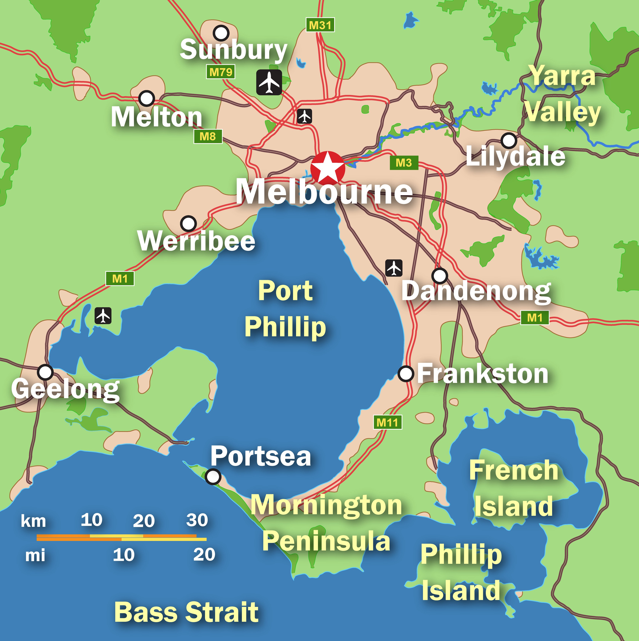
- Frankston and Dandenong:

- Geelong and Melton:

- Lilydale and Werribee:

A HINT:
An easy way to do this is to use a ruler or a piece of string to find the distance between your two points and then check that against the scale.

TASK
Now you know the basics of what makes up a map. Before you move on to creating your own map with your new skills check your understanding. Answer the questions below. Try not to look back on the notes about maps and see what you remember.

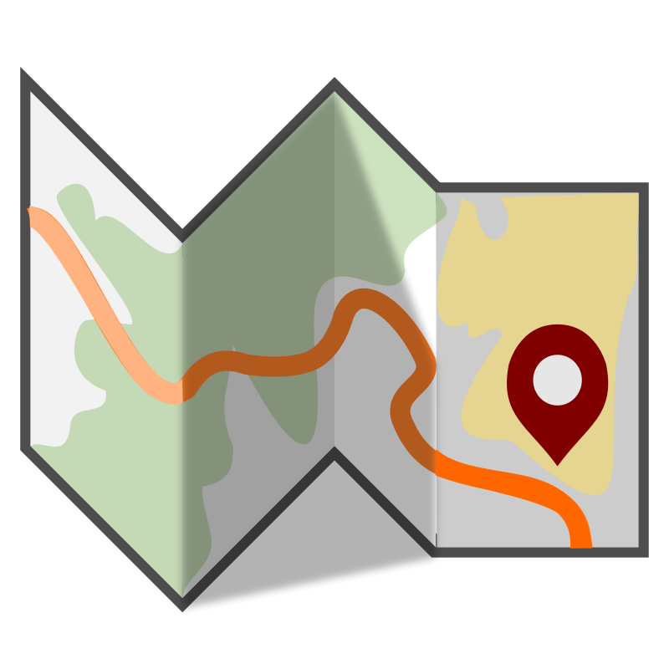
- List what each of the letters in BOLTSS stand for:
B:
O:
L:
T:
S:
- Fill in this compass with the correct compass points labelled:
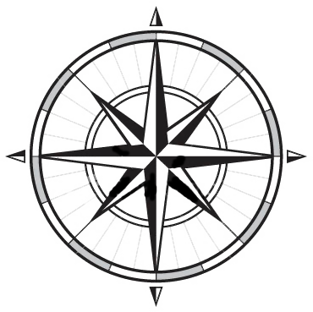

- What does it mean when you say a map must list its source?

- What are 2 requirements of a good map symbol?

- Indicate one way you can show the scale of 1 centimeter equals 5 kilometers on a map.

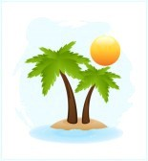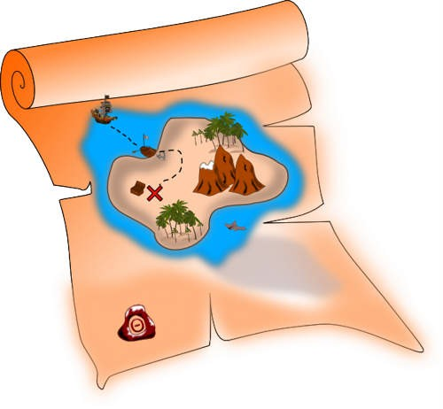

Survival on a
Deserted Island
You have been shipwrecked and have spent 12 months alone on a deserted island. You have decided to make a map and keep records of this experience.

Follow the steps below to create your island:

You can choose to create on white paper and upload photo to Itslearning or create a digital map using any platform you are comfortable using (i.e. Paint, Minecraft,
Adobe)

- Draw your island. Any shape you wish. Be creative!

- Name your island.

- You must show the following features on your island:
  - 2 beaches
  - An area of Coconut palms
  - A rainforest
  - A coral reef
  - A swamp
  - Add in 3 areas of choice (Mountains, Port, a town you created)
You must include each of these items with appropriate symbols, which then must be included and named in your legend.

- Name the surrounding bodies of water.

- Ensure you have all components of B.O.L.T.S.
Border, Orientation, Legend, Title, Scale

- Color your island; make it visually attractive and interesting.

